* **How to give login access to the clients?**  
  To give login access to clients, Go to CRM – Client master and click on edit. Enter login Id check allow mobile access and enter access expiry date and click on save option.

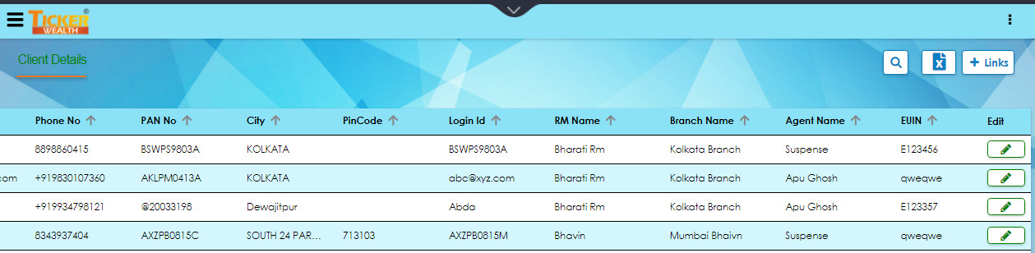

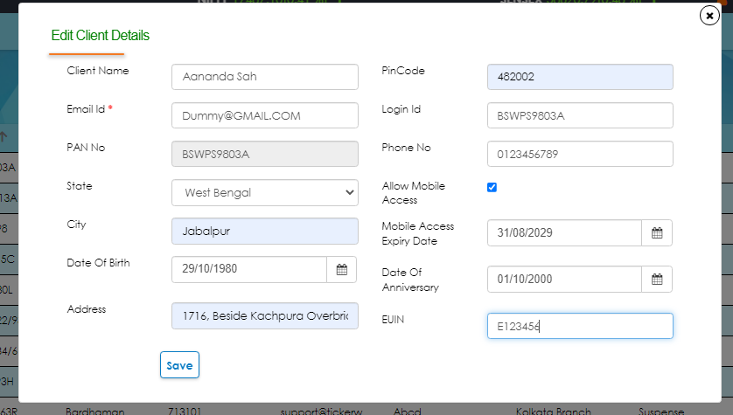

* **How to create Family?**  
  To create a family go to CRM- Family master – Create family.   
  In the search mail client add the head of the family and rest family members can be added through search client option below. After adding all the family members click on submit option.

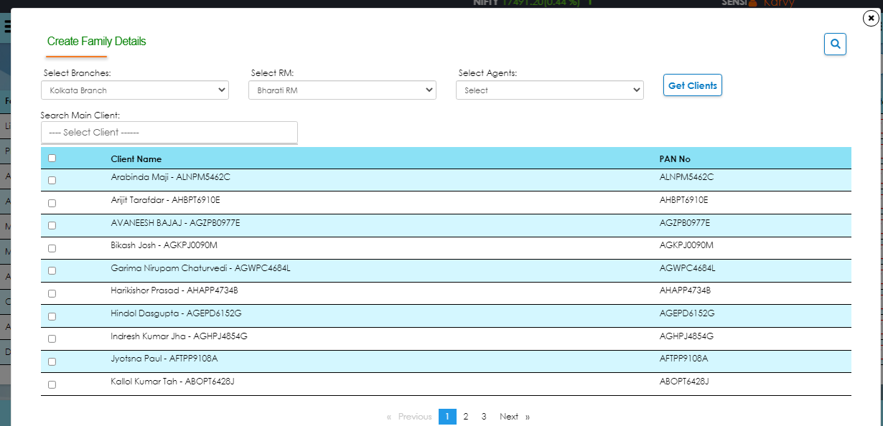

* **How do I merge clients?**

To merge clients, go to CRM- Client merging – Merge Client.

To merge the client, select the main client and add it in the search main client option and add rest of the through below search options.

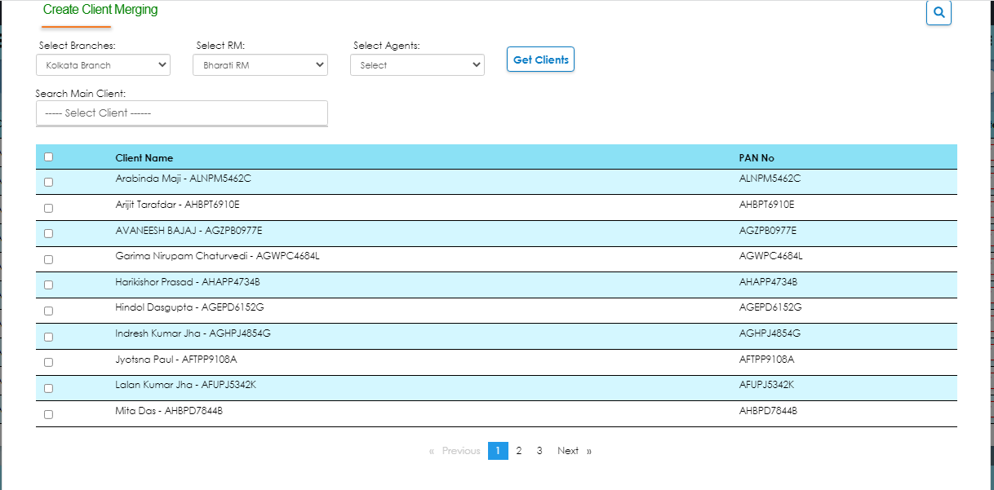

* **How to add Branch, RM and Agents?**

To create branch, go to branch master and click on add branch option  .

Fill the details and click on create option.

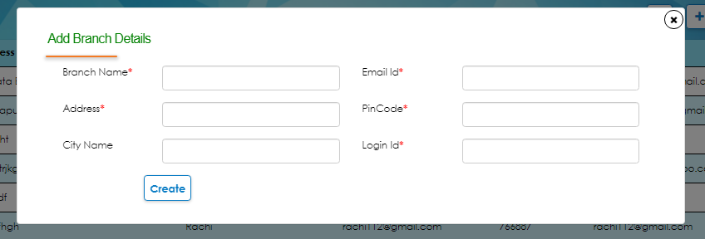

To create RM, go to RM master and click on add RM option.

Fill the details and click on create option.

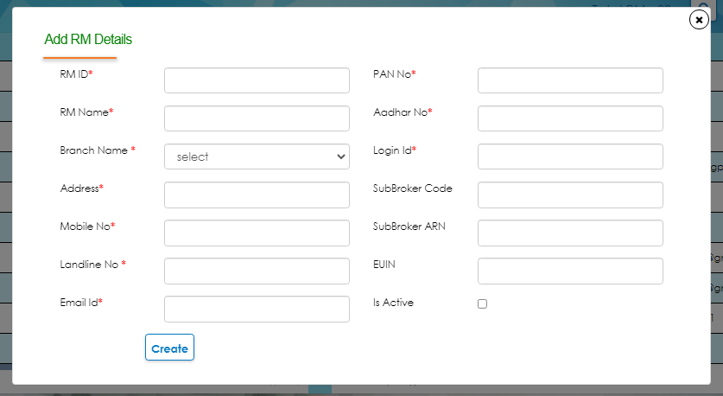

To create agent, go to agent master and click on add agent option.

Fill the details and click on create option.

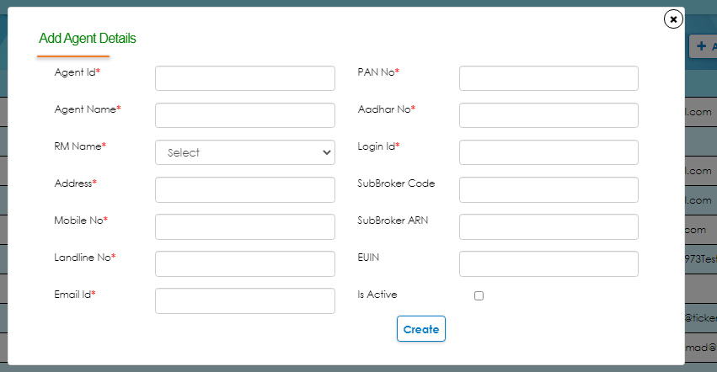

* **What is agent client link master?**

This option can be used to link the client to map it to particular agent.

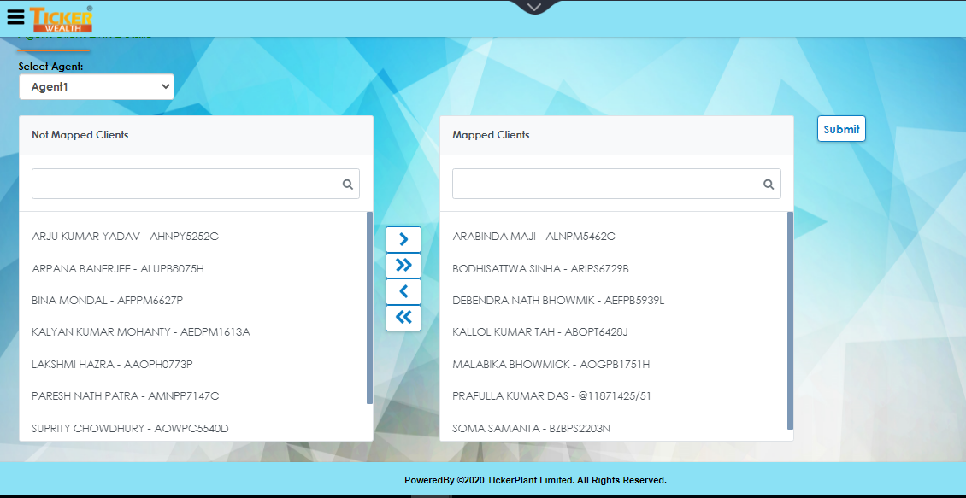

Select a client from not mapped client and trasnafer it to mapped client option and click on submit option.

* **What is RM client link master?**

This option can be used to link the client to map it to particular RM.

Select a client from not mapped client and trasnafer it to mapped client option and click on submit option.

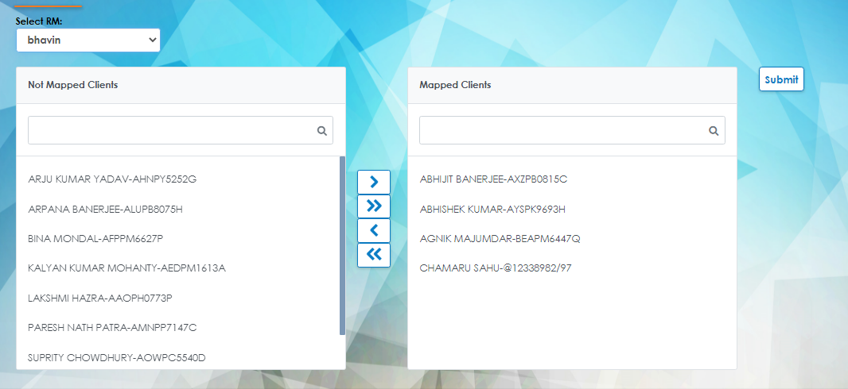

* **What is folio details?**

In folio detail IFA/distributor can see the details mapped against that folio like client name, PAN, scheme name, account number, IFSC code, account type, bank name , branch name and joint holder name. And this report can also download in the excel format.

